234.2

#include<iostream>

using namespace std;

class student

{ public:

void input(student &stu);

void output(student &stu);

private:

char name[20];

unsigned int id;

double score;

};

void student::input(student &stu)

{ cout<<"name?";

cin>>stu.name;

cout<<"id?";

cin>>stu.id;

cout<<"score?";

cin>>stu.score;

}

void student::output(student &stu)

{ cout<<"name:"<<stu.name<<"\tid:"<<stu.id<<"\tscore:"<<stu.score<<endl; }

int main()

{ student s;

s.input(s);

s.output(s);

}

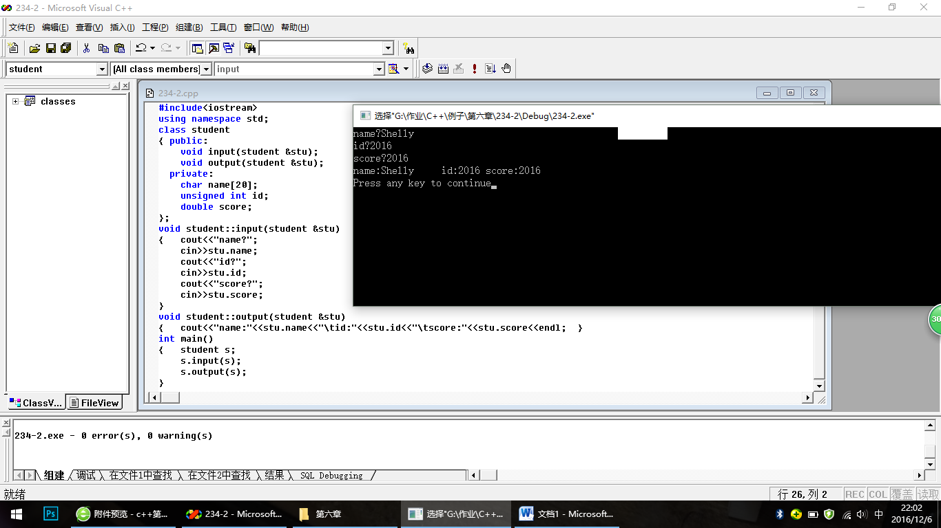

242.1

#include<iostream>

using namespace std;

class book

{ public:

void display();

void borrow();

void restore();

char bookname[20];

double price;

int number;

};

void book::display()

{ cout<<"书名："<<bookname<<endl;

cout<<"价格："<<price<<endl;

cout<<"存书数量："<<number<<endl;

};

void book:: borrow()

{ number=number-1;

cout<<"当前存书数量："<<number<<endl;

};

void book:: restore()

{ number=number+1;

cout<<"当前存书数量："<<number<<endl;

};

int main()

{ book a;

cout<<"Please input bookname:";

cin>>a.bookname;

cout<<"Please input price:";

cin>>a.price;

cout<<"Please input number:";

cin>>a.number;

a.display();

a.borrow();

a.restore();

}

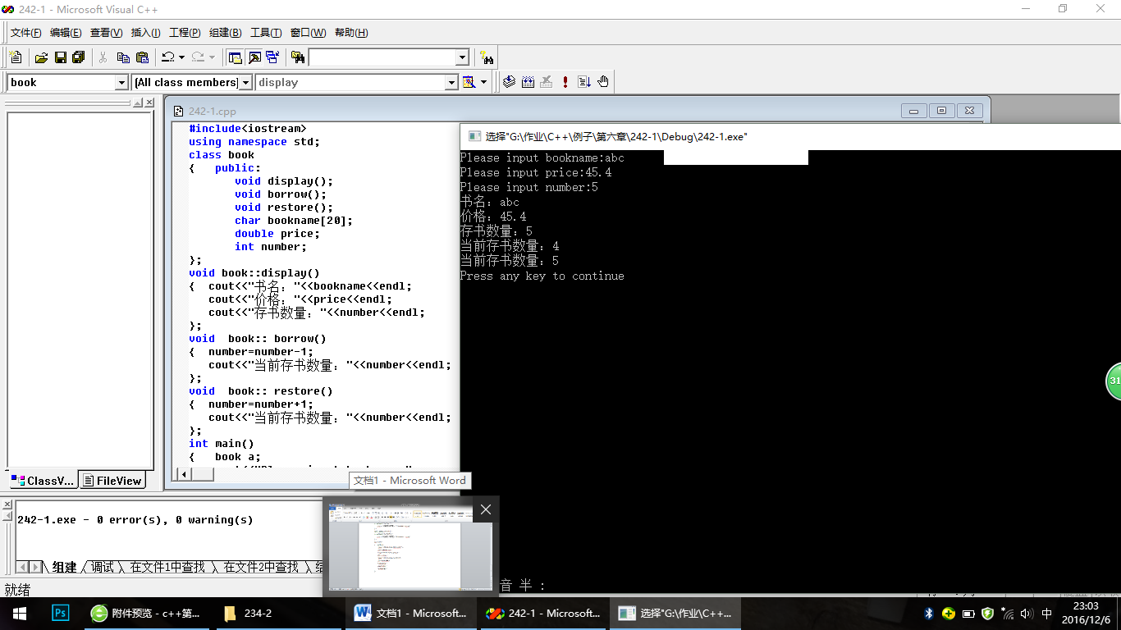

242.3

#include<iostream>

using namespace std;

class student

{ public:

void scoretotalcount(double );

double sum();

double average();

private:

double score;

static double total;

static int count;

};

void student::scoretotalcount(double s)

{ score=s;

total=total+score;

count=count+1;

};

double student::sum()

{ return total; };

double student::average()

{ return total/count; };

double student::total=0;

int student::count=0;

int main()

{ int n;

double s;

student a;

cout<<"请输入学生数量：";

cin>>n;

for(int i=1;i<=n;i++)

{ cout<<"第"<<i<<"位学生的成绩：";

cin>>s;

a.scoretotalcount(s);

}

cout<<"全班同学的总分："<<a.sum()<<endl;

cout<<"全班同学的平均分："<<a.average()<<endl;

}

